AFFIDA VIT OF PUBLICA TION

# STATE OF WASHINGTON COUNTY OF GRANT

I, Blaze Griffith-Steele, do solemnly swear that I am the Principle Agent of the Columbia Basin Herald, a newspaper established and regularly published five days a week in the English language, in and of general circulation continuously for more than six (6) months prior the 31st day of March, 1944; that said newspaper is printed in an office maintained at its place of publication in the City of Moses Lake, Washington; that said newspaper was approved and designated as a legal newspaper by the order of the Superior Court of the State of Washington for Grant County on the 31 st day of March, 1944; and that said order has not been revoked and is in full force and effect.

That the annexed is a true copy of Legal Notice # 06006/23394 MRSC Rosters Legal Notice Eastern WA as it was published in regular issues (and not in supplement form) of said newspaper once each DAY for a period of 1 consecutive DAY commencing on the 3RD of JUNE 2024 and ending on the 3RD of JUNE 2024 both dates inclusive and that such newspaper was regularly distributed to its subscribers during all of said period, that the full amount of fee charged for the foregoing publication is the sum of $230.51

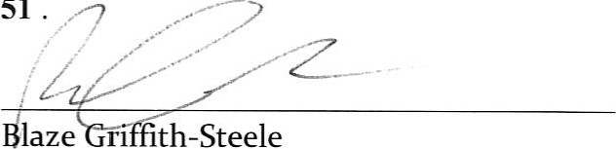

laze

rl

th-Steele

Subscribed and sworn to before me this 3RD DAY OF JUNE 2024,

|  |
| --- |
| ROBERT RAY RICHARDSON Notary Public  State of Washington  Commission # 21034179  My Comm. Expires Nov 4, 2025 |

Notary Public in and for the State of Mlashington

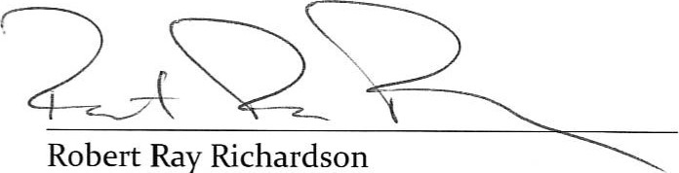

Ray

Richardson

Residing in Moses Lake, Washington

|  |  |
| --- | --- |
| Invoice Number | 0000023394-06032024 |
| Customer | MRSC ROSTERS* |
| Account Number | 5521 |
| Billing Date | 06/03/2024 |
| Description | #06006123394 MRSC Rosters Legal Notice Eastern WA |

Columbia Basin Herald

PO BOX 910

MOSES LAKE, WA 98837

(509) 7654561

ADVERTISING INVOICE

|  |  |  |  |  |  |  |  |  |  |  |  |
| --- | --- | --- | --- | --- | --- | --- | --- | --- | --- | --- | --- |
| |  | | --- | | MRSC ROSTERS*  1712 6th Ave, Suite 100 PMB 1330  Tacoma, WA 98405 | | |  |  |  | | --- | --- | --- | | BILLING DATE |  | REMITTANCE ADDRESS | | 06/03/2024 | Columbia Basin Herald  PO BOX 7000  COEUR D ALENE, ID 83816 | | FD ACCOUNT NUMBER | | 5521 | | ADVERTISER NUMBER | | 5521 | |

MAKE CHECKS PAYABLE TO: Columbia Basin Herald

## PLEASE DETACH AND RETURN UPPER PORTION WITH YOUR REMITTANCE

Columbia Basin Herald

|  |  |  |  |  |
| --- | --- | --- | --- | --- |
| Ad Number | Billing Date | Copy Line | Size  Total Price | |
| 0000023394 | 06/03/2024 | #06006123394 MRSC Rosters Legal Notice  Eastern WA | 3 x 6.214" (49 lines) | $230.51 |
| Total Amount Due | $230.51 |

Advertiser Information

* Past due accounts are subject to finance charges of 1-112% per month, which is an annual percentage of 18%, applied to the previous balance. 'PI' = Per Column Inch, 'FL' = Flat Rate, 'CR' = Contract Rate

06/12/2024 14:37:34