~~[~~

~~def:$signername|printname|req|signer1] [def:$signersig|sig|req|signer1] [def:$notarysig|sig|req|notary] [def:$date|date|req|notary] [def:$state|state|req|notary] [def:$county|county|req|notary] [def:$disclosure|disclosure|req|notary] [def:$seal|seal|req|notary~~

~~]~~

**AFFIDAVIT OF PUBLICATION**

State of Pennsylvania, County of Lancaster, ss:

Casey Allen, being first duly sworn, deposes and says: That (s)he is

a duly authorized signatory of Column Software, PBC, duly

authorized

agent of Douglas County Empire Press, a newspaper

printed and published in the City of East Wenatchee, County of

Douglas, State of Washington, and that this affidavit is Page 1 of 2

with the full text of the

sworn-to notice set forth on the pages that

follow, and the hereto attached:

**PUBLICATION DATES:**

Jun. 6, 2024

**NOTICE ID:**

m6GjL9BHQlpNA1Z1a4Fj

**PUBLISHER ID:**

EPR000241

**NOTICE NAME:**

MRSC Rosters Legal Notice Eastern WA

**Publication Fee:**

193.03

I certify (or declare) under penalty of perjury under the laws of the

State of Washington that the foregoing is true and correct

[

$signersig

]

(

Signed)______________________________________

[

$seal

]

**VERIFICATION**

State of Pennsylvania

County of Lancaster

Subscribed in my presence and sworn to before me on this:

]

$date

[

[

$notarysig

]

______________________________

Notary Public

[

$disclosure

]

See Proof on Next Page



Notarized r

emotely online using communication technology via Proof.

06/11/

2024

MRSC Rosters Legal Notice Eastern WA - Page 1 of 2

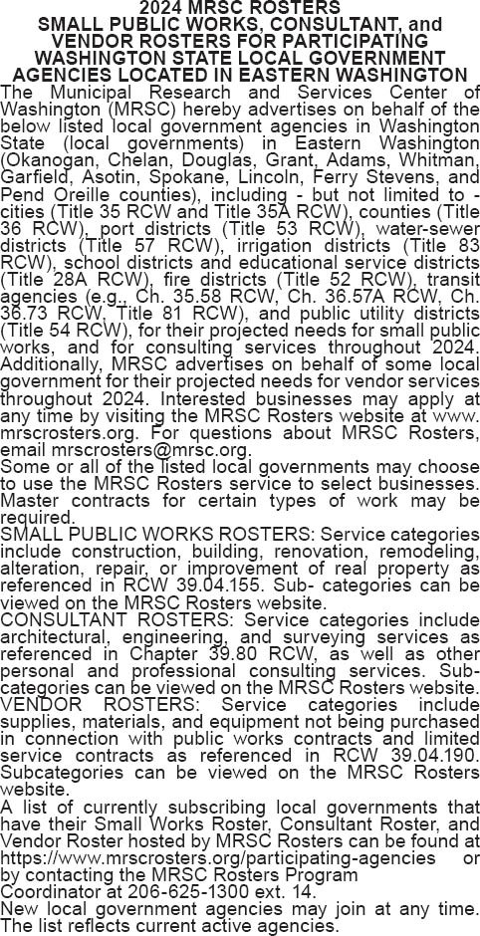

MRSC Rosters Legal Notice Eastern WA - Page 2 of 2