 t9eSeattetitnes

AFFIDAVIT OF PUBLICATION

Accounts Payable

Municipal Research

1712 6th Ave Ste 100

PMB1330

Tacoma WA 98405

STATE OF WASHINGTON, COUNTIES OF KING AND SNOHOMISH

The undersigned, on oath states that he/she is an authorized representative of The Seattle Times Company, publisher of The Seattle Times of general circulation published daily in King and Snohomish Counties, State of Washingtoo. The Seattle Times has been approved as a legal newspaper by orders of the Superior Court of King and Snohomish Counties. 

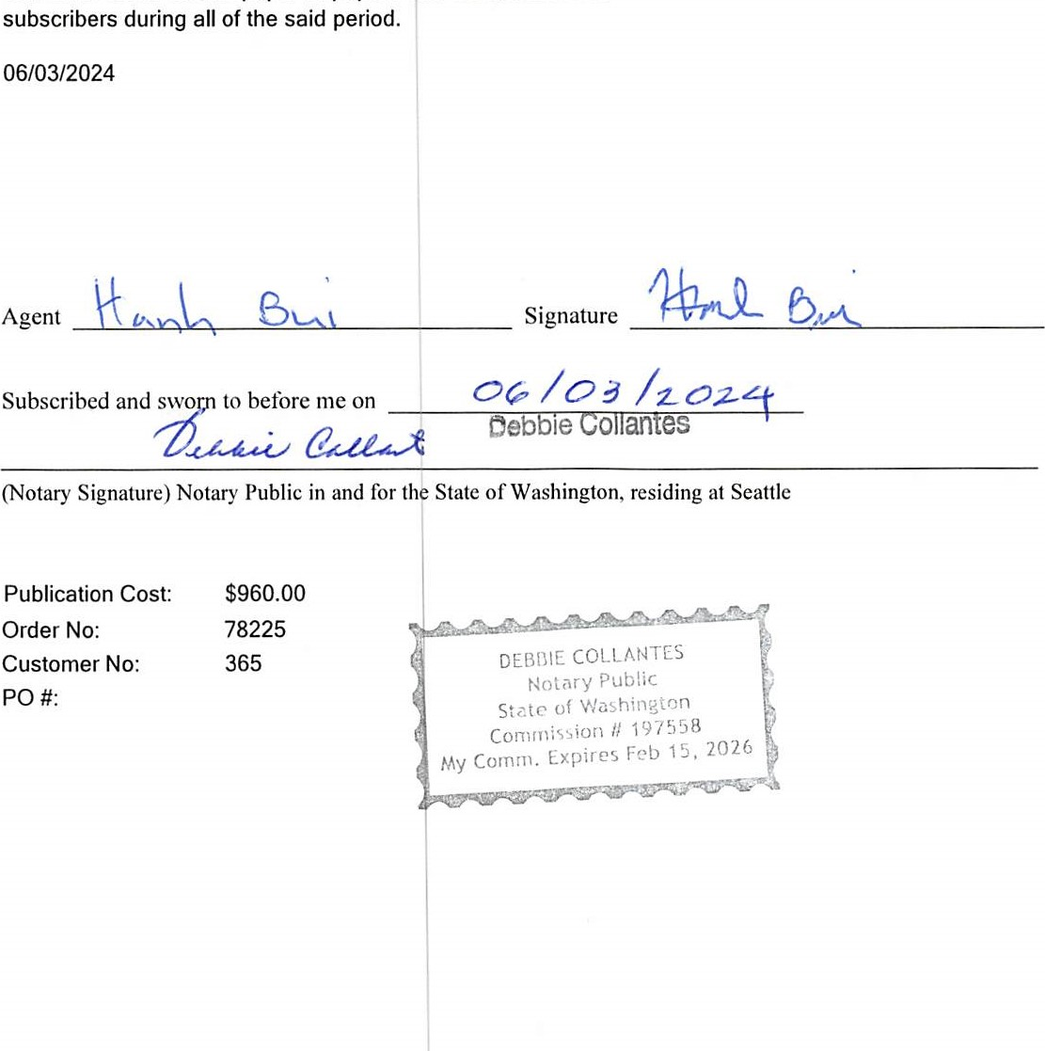

Page

1

The notice, in the exact form annexed, was published in the regular and entire issue of said paper or papers and distributed to its

06/03/2024

Agent

 2024 MRSC ROSTERSPublication Cost: $960.00

SMALL PUBLIC WORKS,

CONSULTANT, and VENDOR ROSTEROrder No: 78225

FOR PARTICIPATING WASHINGTON

STATE LOCAL GOVERNMENTCustomer No: 365

AGENCIES LOCATED IN

WESTERN WASHINGTON PO

The Municipal Research and Service Center of Washington (MRSC) hereby advertises on behalf of the below listed local government agencies in Washing• ton State (local governments) in West ern Washington (Whatcom, Skagit, Sa Juan, Island, Snohomlsh, King, Pierce, and Thurston counties), including • but not limited to - cities (Title 35 RCW and Title 35A RCW), counties (Title 3 RCW), port districts (Title 53 RCW) water-sewer districts (Title 57 RCW) irrigation districts (Title 83 RCW)i school districts and educational service districts (Title 28A RCW), fire districts (Title 52 RCW), transit agencies (e.g.) Ch. 35.58 RCW, Ch. 36.57A RCW, Ch. 36.73 RCW, Title 81 RCW), and public utility districts (Title 54 RCW), for their projected needs for small public works, and for consulting services throughout 2024. Additionally, MRSC advertises on behalf of some local ernment for their projected needs for vendor services throughout 2024. Interested businesses may apply at any time by visiting the MRSC Rosters website at www.mrscrosters.org. For questions about MRSC Rosters, email mrscrosters@mrsc.org.

Some or all of the listed local governments may choose to use the MRSC Rosters service to select businesses. Master contracts for certain types of work may be required.

SMALL PUBLIC WORKS ROSTERS: Service categories include construction, building, renovation, remodeling q alteration, repair, or improvement ofl real property as referenced in RCW 39.04.155. Sub-categories can be viewed on the MRSC Rosters website.

CONSULTANT ROSTERS: service categories include architectural, engineering, and surveying services as refer• enced in Chapter 39.80 RCW, as well as other personal and professional consulting services. Sub-categories can be, viewed on the MRSC Rosters website.

VENDOR ROSTERS: Service categories include supplies, materials, and! equipment not being purchased in connection with public works contracts and limited service contracts as referenced in RCW 39.04.190. Subcategories can be viewed on the MRSC Rosters website.

A list of currently subscribing local governments that have their Small Works Roster, Consultant Roster, and Vendor Roster hosted by MRSC Rosters can be found at https://www.mrscros ters.org/partlclpating-agencies or by contacting the MRSC Rosters Program Coordinator at 206-625-1300 ext. 14.

New local government agencies may Join at any time. The list reflects current active agencies.

Page 2