CT Publishing LLC d/b/

Page of 1

|  |
| --- |
| 130341 2024 MRSC ROSTERS  2024 MRSC ROSTERS  SMALL PUBLIC WORKS,  CONSULTANT, and VENDOR ROSTERS  FOR PARTICIPATING WASHINGTON STATE  LOCAL GOVERNMENT AGENCIES  LOCATED IN SOUTHWEST WASHINGTON  The Municipal Research and Services Center Of Washington (MRSC) hereby advertises on behalf of the below listed local government agencies in Washington State (local governments) in Southwest Washington (Pacific, Lewis, Wahkiakum, Cowlitz, Clark, and Skamania counties), including - but not limited to - cities (Title 35 RCW and Title 35A RCW), counties (Title 36 RCW), port districts (Title 53 • ROW), water-sewer districts (Title 57 ROW), irrigation districts (Title 83 RCW), school districts and educational service districts (Title 28A RCW), fire districts (Title 52 RCW), transit agencies (e.g., Ch. 35.58 ROW, Ch. 36.57A RCW, Ch. 36.73 RCW, Title 81 RCW), and public utility districts (Title 54 ROW), for their projected needs for small public works, and for consulting services throughout 2024. Additionally, MRSC advertises on behalf of some local government for their projected • needs for vendor services throughout 2024. Interested businesses may apply at any time by visiting the MRSC Rosters website at www.mrscrosters.org. For questions about MRSC Rosters, email mrscrosters@mrsc.org.  Some or all of the listed local •governments may choose to use the MRSC Rosters service to select businesses. Master contracts for certain types of work may be required.    SMALL PUBLIC WORKS ROSTERS: Service categories include  construction, building, renovation, remodeling, alteration, repair, or improvement of real property as referenced in RCW 39.04.155. Sub-categories can be viewed on the MRSC Rosters website.      CONSULTANT ROSTERS: Service categories include architectural, engineering, and surveying services as referenced in Chapter 39.80 ROW, as well as other personal and professional consulting services. Sub-categories can be viewed on the MRSC Rosters website.    VENDOR ROSTERS: Service categories include supplies, materials, and equipment not being purchased in connection with public works contracts and limited service contracts as referenced in RCW 39.04.190. Subcategories Can be viewed on the MRSC Rosters website.        A list of currently subscribing local governments that have their Small Works Roster, Consultant Roster, and Vendor Roster hosted by MRSC Rosters can be found at  contacting the MRSC Rosters Program Coordinator at 206-625-1300 ext. 14.      New local government agencies may join at any time. The list reflects current active agencies.  Published:  June |
|
|
|

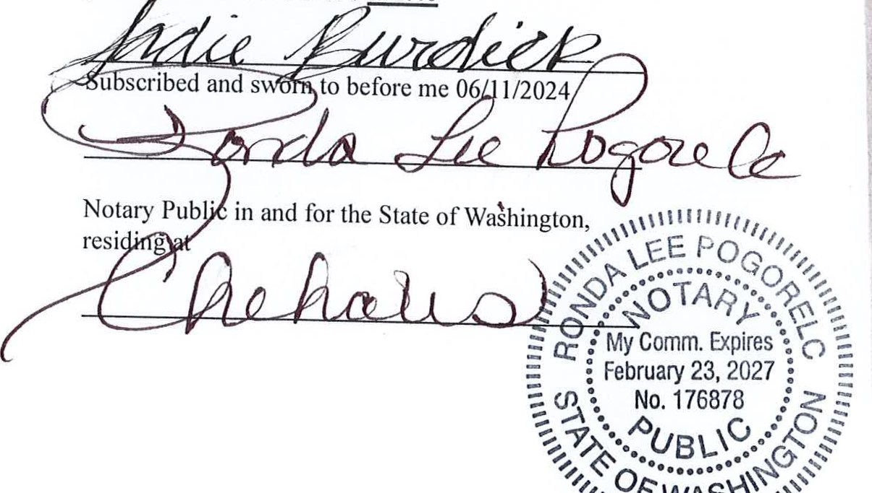AFFIDAVIT

OF PUBLICATION

STATE OF WASHINGTON COUNTY OF LEWIS

Sadie Burdick, and/or Sarah Burdick, and/or Ronda Pogorelc and/or Cheyenne Denman says that she is the legal clerk of

# Cbroniclt

a semi-weekly newspaper, which has been established, published in the English language, and circulated continuously as a semi-weekly newspaper in the City of Centralia, and in Lewis County, Washington, general circulation in Lewis County for more than six (6) months prior to the date of the first publication of the notice hereto attached, and that the said Chronicle was on the 7th day of July 1941, approved as a legal newspaper by the Superior Court of said Lewis County. And that the attached is a true copy and was published in regular issues (and not in supplement form) of said newspaper as LEGAL 130341 RE:2023 MRSC ROSTERS

once each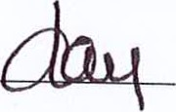for a period of 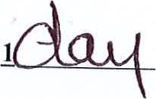1

commencing on 06/11/2024 and ending on 06/11/2024

and both regularly distributed to its subscribers during all of said period. That the full amount of the fee charged for the foregoing public tion is the sum of S 431.40