

AFFIDAVIT OF PUBLICATION

|  |  |  |  |  |  |  |
| --- | --- | --- | --- | --- | --- | --- |
| Account # | Order Number | Identification | Order PO | Amount | Cols | Depth |
| 126309 | 550833 | Print Legal Ad-IPL01726050 - IPL0172605 |  | $395.82 | 1 | 86 L |

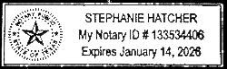Mary Castro, being duly sworn, deposes and says: That he/she is the Principal Clerk of The Bellingham Herald, a daily newspaper printed and published in Bellingham, Whatcom County, State of Washington, and having a general circulation therein, and which said newspaper has been continuously and uninterruptedly published in said County during a period of six months prior to the first publication of the notice, a copy of which is attached hereto: that said notice was published in The Bellingham Herald, as amended, for:

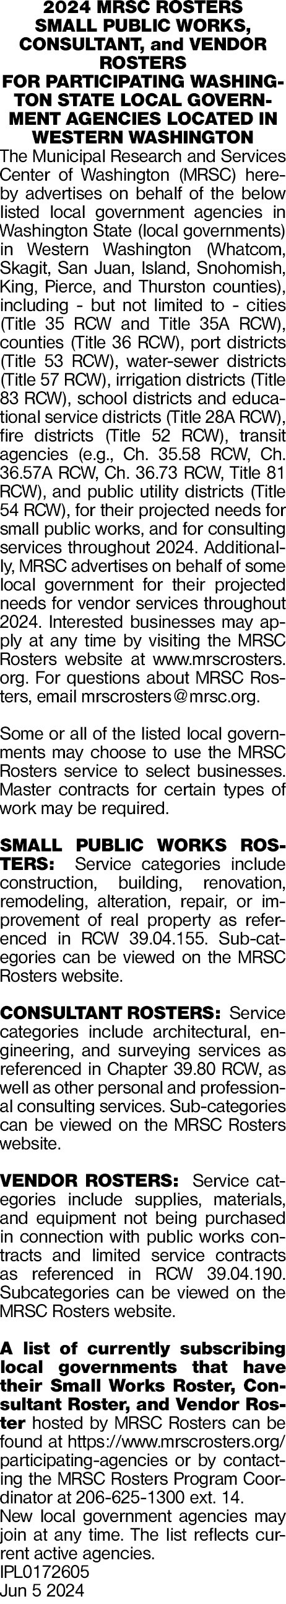

MRSC

2601 4

th Avenue, Suite

800

Seattle, WA 98121

Attention:

Aimy Enriquez

tgonzales@mrsc.org

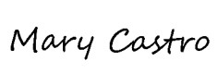

(

Principal Clerk

)

Subscribed and sworn on this 5th day of June in the



Notary Public in and for the state of Texas, residing in

Dallas County

1 insertion(s) published on:

06/05/24

year of 2024 before me, a Notary Public, personally appeared before me Mary Castro known or identified to me to be the person whose name subscribed to the within instrument, and being by first duly sworn, declared that the statements therein are true, and acknowledged to me that he/she executed the same.

Extra charge for lost or duplicate affidavits. Legal document please do not destroy!