~~[~~

~~def:$signername|printname|req|signer1] [def:$signersig|sig|req|signer1] [def:$notarysig|sig|req|notary] [def:$date|date|req|notary] [def:$state|state|req|notary] [def:$county|county|req|notary] [def:$disclosure|disclosure|req|notary] [def:$seal|seal|req|notary~~

~~]~~

**AFFIDAVIT OF PUBLICATION**

State of Florida, County of Orange, ss:

Kevin Richman, being first duly sworn, deposes and says: That

(

s)he is a duly authorized signatory of Column Software, PBC, duly

authorized

agent of Wenatchee World, a newspaper printed and

published in the City of Wenatchee, County of Chelan, State of

Washington, and that this affidavit is Page 1 of 2 with the full text of

the

sworn-to notice set forth on the pages that follow, and the hereto

attached:

**PUBLICATION DATES:**

Jun. 4, 2024

**NOTICE ID:**

lFzUb1Dsv21H4FBc07pX

**PUBLISHER ID:**

WWO000676

**NOTICE NAME:**

MRSC Rosters Legal Notice Eastern WA

**Publication Fee:**

247.85

I certify (or declare) under penalty of perjury under the laws of the

State of Washington that the foregoing is true and correct

[

$signersig

]

(

Signed)______________________________________

[

$seal

]

**VERIFICATION**

State of Florida

County of Orange

Subscribed in my presence and sworn to before me on this:

$date

[

]

]

[

$notarysig

______________________________

Notary Public

[

$disclosure

]

See Proof on Next Page

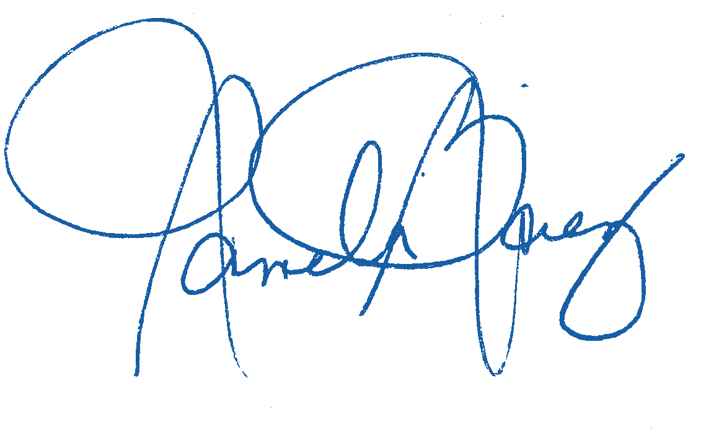

Notarized r

emotely online using communication technology via Proof.

2024

06/10/



MRSC Rosters Legal Notice Eastern WA - Page 1 of 2

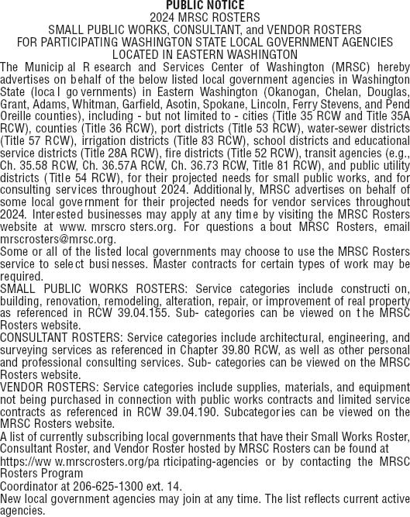

MRSC Rosters Legal Notice Eastern WA - Page 2 of 2