

AFFIDAVIT OF PUBLICATION

|  |  |  |  |  |  |  |
| --- | --- | --- | --- | --- | --- | --- |
| Account # | Order Number | Identification | Order PO | Amount | Cols | Depth |
| 126309 | 557264 | Print Legal Ad-IPL01751660 - IPL0175166 |  | $238.54 | 1 | 86 L |

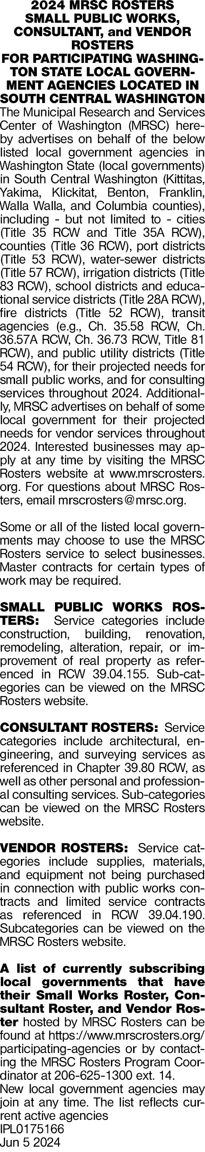

Aimy Enriquez

Attention:

MRSC

2601 4

th Avenue, Suite

800

Seattle, WA 98121

tgonzales@mrsc.org

COUNTY OF BENTON)

SS

STATE OF WASHINGTON)

Mary Castro, being duly sworn, deposes and says, I am

the Legals Clerk of The Tri-City Herald, a daily

newspaper. That said newspaper is a local newspaper

and has been approved as a legal newspaper by order of

the superior court in the county in which it is published

and it is now and has been for more than six months

prior to the date of the publications hereinafter referred

to, published continually as a daily newspaper in Benton

County, Washington. That the attached is a true copy as

it was printed in the regular and entire issue of the Tri-

City Herald and not in a supplement thereof, ran 1 time

(

s) commencing on 06/05/2024, and ending on

06

/05/2024 and that said newspaper was regularly

distributed to its subscribers during all of this period.

1

insertion(s) published on

:

06

/05/

24



(

)

Signature of Legals Clerk

Sworn to and subscribed before me this 5th day of

June in the year of 2024



Notary Public in and for the state of Texas, residing in

Dallas County

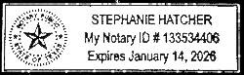

Extra charge for lost or duplicate affidavits.

Legal document please do not destroy!