2024 MRSC ROSTERS

SMALL PUBLIC WORKS,

CONSULTANT, and VENDOR

# ROSTERS

FOR PARTICIPATING

WASHINGTON STATE LOCAL'

GOVERNMENT AGENCIES LOCATED IN SOUTH CEN-

TRAL WASHINGTON

The Municipal Research and

Services Center of Washington (MRSC) hereby advertises on behalf of the below listed local government agencies in Washington State (local governments) in South Central Washington (Kittitas, Yakima,

 Klickitat, Benton, Franklin, Walla Walla, and Columbia  counties), including - but not limited to - cities (Title 35 RCW and Title 35A RCW), counties (Title 36 RCW), port districts (Title 53 RCW), water-sewer districts (Title 57 RCW), irriga• tion districts (Title 83 RCW), échöol districts and education-j al service districts (Title 28A RCW), fire districts (Title 52

RCW), transit agencies (e.g.,

Ch. 35.58 RCW, Ch. 36.57A

RCW, Ch. 36.73 RCW, Title 81 RCW), and public utility districts (Title 54 RCW), for their projected needs for small public wo/ks, and for consulting services throughout 2024. Additionally, MRSC advertises on behalf of some local government for their projected needs for vendor services throughout 2024. Interested businesses may apply at any time by visiting the MRSC Rosters website at www. mrscrosters.org. For questions about MRSC Rosters, email mrscrosters@mrsc.org. Some or all of the listed local governments may choose to use the MRSC Rosters service to select businesses. Master contracts for certain types of work may be required. SMALL PUBLIC WORKS ROSTERS: Service categories include construction, building, renovation, remodeling, alteration, repair, or improvement of real property as referenced in RCW 39.04.155. Sub-categories can be viewed on the MRSC Rosters website.

CONSULTANT ROSTERS:

Service categories include architectural, engineering, and surveying services as referenced in Chapter 39.80 RCW, as well as other personal and professional consulting services. Sub-categories can be viewed on the MRSC Rosters website. VENDOR ROSTERS: Service categories include supplies, materials, and equipment not being purchased in connection with public works contracts and limited service contracts as referenced in RCW

Proof of

# Publication

The Times Case No. 20120945111794

STATE OF WASHINGTON, )

County of Walla Walla 

Lane Gwinn, being first duly sworn on oath, deposes and says: That she is the Publisher of The Times, a weekly newspaper which has been established, published in the English language, and circulated continuously as a weekly newspaper in the City of Waitsburg, and in said County and State, and of general circulation in said County for more than six (6) months prior to the date of the first publication of the Notice hereto attached.

That said newspaper is the official newspaper of the City of

Waitsburg and the County of Walla Walla.

That The Times was, on the 14th day of September 1955, approved as a legal newspaper by the Superior Court of said Walla Walla County, and that the annexed is a true copy of a

Small Works Roster

MRSC

6-6-e

as it appeared in the regular and entire issue of said newspaper itself and not in a supplement thereof for a period of 1 week, beginning the 6th day of June and ending the 6th day of June 2024, and that said newspaper was regularly distributed to its subscribers during all of this period.

That the full amount is $130.00at the rate of $10.00 per column inch.

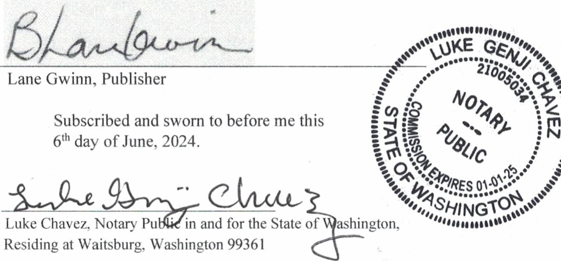

Small Works Roster

MRSC

6-6-e

Page 2 of2 39.04.190. Subcategories can be viewed on the MRSC Rosters website.

A list of currently subscribing local governments that have

; their Small Works Roster,

Consultant Roster, and Vendor

Roster hosted by MRSC Rosters can be found at https://www.mrscrosters.org/ participating-agencies or by contacting the MRSC Rosters Program Coordinator at 206625-1300 ext. 14. New local government agencies may join at any time. The list reflects current active agencies.

The Times

June 6, 2024

6-6-e