AFFIDAVIT OF PUBLICATION

STATE OF WASHINGTON

COUNTY OF SKAMANIA J

The undersigned, being first duly sworn on oath, deposes and says: That he/she is an authorized representative of the SKAMANIA COUNTY PIONEER, a weekly newspaper, which has been established, published in the English language, and circulated continuously as a weekly newspaper in the City of Stevenson, and in said County and State, and of general circulation in said county for more then six (6) months prior to the date of the first publication of the Notice hereto attached, and that the said Skamania County Pioneer was on the 7th day of July, 1941, approved as a legal newspaper by the Superior Court of said Skamania County, and that the annexed is true copy of the notice in the exact form annexed, was published in regular issues of The Skamania County Pioneer which was regularly distributed to its subscribers during the below stated period. The annexed notice, a



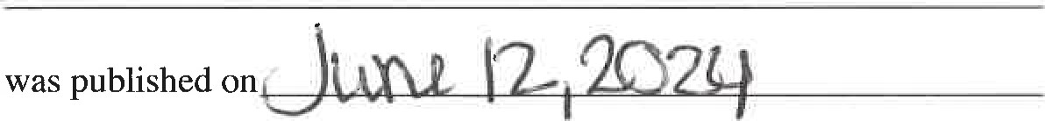

The amount of the fee charged for the foregoing publication is the sum



|  |  |  |  |  |  |  |
| --- | --- | --- | --- | --- | --- | --- |
|  | |  |  |  |  |  |
|  | e | spaper | | | resentative | |

Subscribed and sworn to before me this

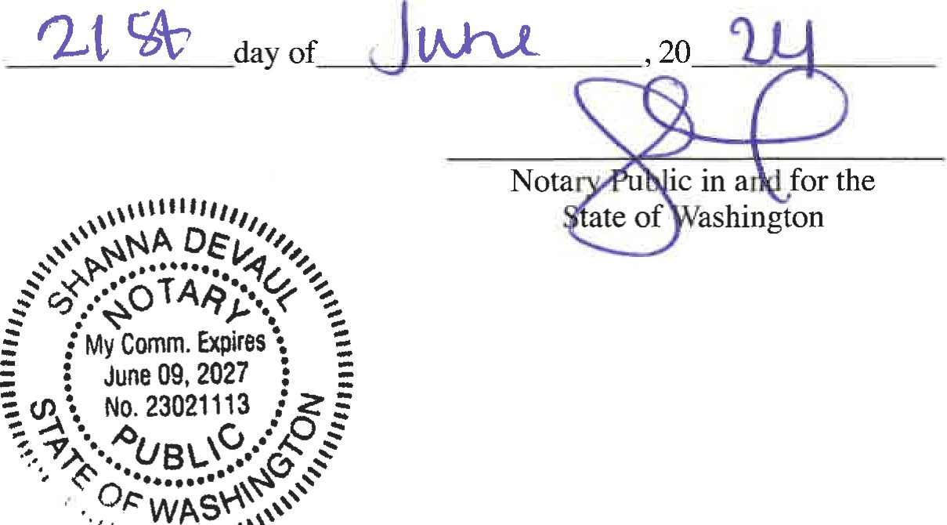

2024 MRSC ROSTERS,

SMALL PUBLIC WORKS,

CONSULTANT, and VENDOR ROSTERS

# FOR PARTICIPATING WASHINGTON STATE

LOCAL GOVERNMENT AGENCIES LOCATED

IN SOUTHWEST WASH-

 INGTON

The Municipal Research and Services Center ofWashington (MRSC) hereby advertises on behalf of the below listed local government agencies in Washington

State (local governments) in Southwest Washington (Pacific, Lewis, Wahkiakum, Cowlitz, Clark, and Skamania counties), in- cluding - but not limited to - cities (Title 35 RCW and Title 35A RCW), counties (Title 36 RCW). port districts (Title 53 RCW), water-sewer districts (Title 57 RCW), irrigation districts (Title 83 RCW), school districts and educational service districts (Title 28A



RCW), fire districts (Title 52 RCW), transit agencieq

(e.g., Ch. 35.58 RCW, Ch. 

# 36.57A RCW, Ch. 36.73

RCW, Title 81 and public utility districts (Title 54 RCW), for their pro- jected needs for small public works, and for consulting services throughout 2024. Additionally, MRSC advertises on behalf of some local government for their projected needs for vendor services throughout 2024. Interested businesses may apply at any time by visiting

the MRSC Rosters website at www.mrscrosters.org. For questions about MRSC Rosters, email mrscrosters@ mrsc.org.

# Some or all of the listed local governments may choose to use the MRSC Rosters service to select

businesses. Master contracts for certain types of work may be required. SMALL PUBLIC WORKS ROSTERS: Service cat. egöries include construction, building, renovation,

remodeling, alteration, repair, or improvement of real property as referenced in RCW 39.04.155. Subcategories can be viewed on the MRSC Rosters website. CONSULTANTROSTERS: Service categories include architectural, engineering, and surveying services 

as referenced in Chapter 39.80 RCW, as well as other personal and professional consulting serVices. Subcategories can be viewed on the MRSC Rosters website. VENDOR ROSTERS:

Service categories include supplies, materials, and equipment not being purchased in connection with public works contracts and limited service contracts as referenced in RCW 39.04.190. Subcategories

can be viewed on the MRSC Rosters website.

A list of currently subscrib- ing local governments that have their Small Works Roster, Consultant Roster, and Vendor Roster hosted by MRSC Rosters can be found at https://www.mrscrosters. org/participating-agencies or by contacting the MRSC Rosters Program Coordina- tor at 206-625-1300 ext. 14. New local government agencies may join at any  time. The list reflects current active agencies. Published in the Skamania

County Pioneer

 June 12, 2024

DEVAUL PUBLISHING INC

## 429 N MARKET BLVD

CHEHALIS, WA 98532 07/08/2024

MID: xxxxxxxxxxxxns TID:

CREDIT CARD

## MC SALE

|  |  |
| --- | --- |
| Card # | xxxxxmmx3788 |
| SEQ | 2 |
| Batch | 296 |
| INVOICE | 2 |
| Approval Code: | 04061J |
| Enty Mehod: | Manual |
| Mode: | Online |
| Tax Amotnt,• | $0.00 |
| Avs Code: Card Code: | YYY |
| SALE AMOUNT | $147,00 |

I agree to pay above btal amount according b card issuer agreement.

## (Merchant agreement if Credit Voucher)



## MERCHANT COPY