Affidavit of Publication

STATE OF WASHINGTON) )ss

# COUNTY OF JEFFERSON)

I, Kathleen Elizabeth Boyd, an employee of the Port Townsend & Jefferson County Leader, a weekly newspaper which has been established, published in the English language and circulated continuously as a weekly newspaper in the town of Port Townsend in said County and State, and for general circulation in said county for more than six (6) months prior to the date of first publication of the Notice hereto attached and that the said Port Townsend & Jefferson County Leader was on the 27th day of June 1941 approved as a legal newspaper by the Superior Court of said Jefferson County and amexed is a true copy of the AD # 

## SEE ATTACHED TEAR SHEET

As it appeared in the regular and entire issue of said paper itself not in a supplement thereof for a period beginning on the day 20 , ending on the day 20 that said newspaper was regul y distributed to their subscribers during all of this period. That the full amount of $ åoq•7.ö has been paid in full.

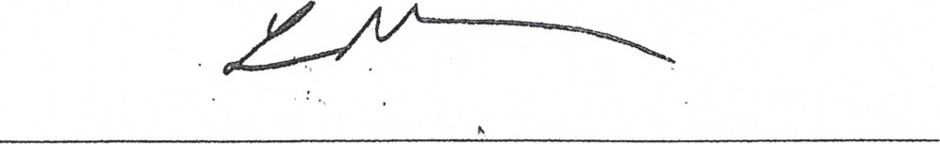

### Lloyd Mullen, Publisher

