## 2024 MRSC ROSTERS

SMALL PUBLIC WORKS,

CONSULTANT, and

## VENDOR ROSTERS FOR PARTICIPATING WASHINGTON STATE

LOCAL GOVERNMENT

AGENCIES LOCATED

## SOUTH CENTRAL

### WASHINGTON

The Municipal Research and Services Center of Washington (MRSC) hereby advertises on behalf of the below listed

local government agencies in Washington State (local governments) in South Central Washington (Kittitas, Yakima, Klickitat, Benton, Franklin, Walla Walla, and Columbia counties), including - but not limited to - cities (Title 35 RCW and Title 35A RCW), counties (Title 36 RCW), port districts (Title 53 RCW), water-sewer districts (Title 57 RCW), irrigation districts (Title 83 RCW), school districts and educational service districts (Title 28A RCW), fire districts (Title 52

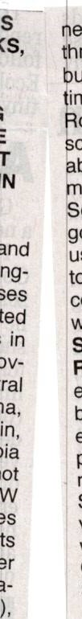

IN



RCW), 35.58 transit RCW, agencies Ch. 36.57A(e.g., Ch.

RCW, Ch. 36.73 RCW, Title 81 RCW), and public utility districts (Title 54 RCW), for heir projected needs for small )ublic works, and for consultng services throughout 2024. \dditionally, MRSC advertises in behalf of some local govrnment for their projected eeds for vendor services roughout 2024. Interested usinesses may apply at any ime by visiting the MRSC osters website at www.mrcrosters.org. For questions bout MRSC Rosters, email rscrosters@mrsc.org.

## ome or all of the listed local AFFIDAVIT OF PUBLICATION

overnments may choose to use the MRSC Rosters service to select businesses. Master contracts for certain types of State Of Washington work may be required.

### SMALL PUBLIC WORKS County of Klickitat

ROSTERS: Service categories include construction, building, renovation, remod- Naomi says: James, That being she first is an duly agent sworn of on The oath, Goldendaledeposes eling, alteration, repair, or im- and provement of real property as Sentinel, a weekly newspaper, which has been referenced in RCW 39.04.155. established, published in the English language, and Sub-categories can be )irculated continuously as a weekly newspaper in the viewed on the MRSC Rosters -sJity of Goldendale, and in said County and State, and of website. ROSTERS: leneral circulation in said County for more than six (6) CONSULTANT categories include ar- nonths prior to the date of the first publication of the Service chitectural, surveying engineering, and Jotice entinel hereto was on attached, the 18th day and of that June, the 1941, said approved Goldendaleas

services as referenced in Chapter 39.80 RCW, legal newspaper by the Superior Court of said Klickitat as well as other personal and ounty, and that the annexed is a true copy. professional consulting services. Sub-categories can be ublic Notice: 2024 MRSC Rosters viewed on the MRSC Rosters

website. ROSTERS: Ser- s it appeared in the regular and entire issue of said VENDOR vice categories include sup- itself and not in a supplement thereof for a period

plies, ment not materials, being purchased and equip-in 024 one and week(s) ending commencing on the 5th day on of the June, 5th 2024 day of and June,that

connection with public works lid newspaper was regularly distributed to its contracts and limited ser- bscribers during all of this period. as referenced

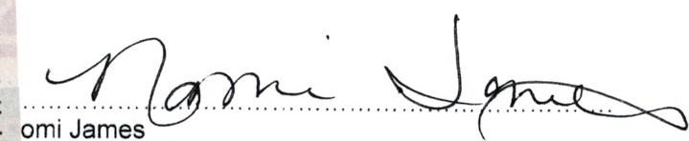vice contracts in RCW 39.04.190. Subcategories can be viewed on the MRSC Rosters website. A list of currently subscribing local governments that

have their Small Works Ros- omi James ter, Consultant Roster, and ent Vendor Roster hosted by MRSC Rosters can be found )scribed and sworn to before me this 5th day of June, at https://www.mrscrosters. org/participating-agencies or by contacting the MRSC Rosters Program Coordinator at 206-625-1300 ext. 14.

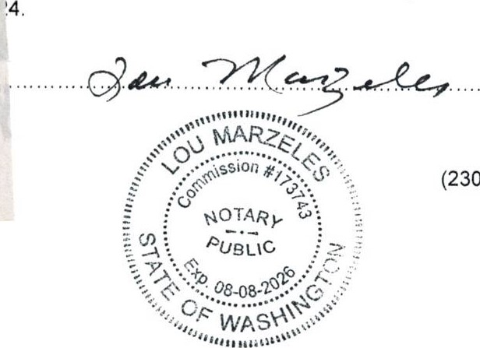

(2307)

New local government agencies may join at any time. The list reflects current active agencies.

(2307)